A PROJECT REPORT ON

“Oppo E-commerce Website”
SUBMITTED IN PARTIAL FULFILLMENT OF THE REQUIREMENT FOR THE AWARD OF THE DEGREE BACHELOR OF COMPUTER APPLICATION

SESSION : 2022 – 2025
Project Guide Name: Submitted By
_____________________ Name of Student:
Nitin Chaurasiya
Enrollment No.:
Internal Guide: AY148055003
Mr. Giriraj Harode Roll No. :
(BCA Faculty) Study Institute code No: 8055
Submitted to
Makhanlal Chaturvedi National University of
Journalism and Communication, Bhopal
Name of Study Institute
Vikramaditya Institute of Computer Science & Technology Bhopal (8055)

Project Certificate

This is to certify that the project report entitled Oppo E-commerce Website submitted to Makhanlal Chaturvedi National University of Journalism & Communication Bhopal, in partial fulfillment of the requirement for the award of the degree of BACHELOR OF COMPUTER APPLICATIONS (BCA), is original work carried out by myself Mr / Ms Nitin Chaurasiya with enrolment no.AY148055003. Under the Supervision of Prof./Dr./Mr./Ms.__________________.
The matter embodied in this project is genuine work done by myself and has not been submitted whether to this University or to any other University / Institute for the fulfillment of the requirement of any course of study.

Date:
Name & Signature of the Student
Contact Details (Email, Phone & Address)
……Nitin
Chaurasiyanitin264@gmail.com
7067580134……….. ……………………..……..

Verified by the Supervisor
Name & Signature of the Supervisor/s
Date:………………..

Acknowledgement

This Major Project is the result of contribution of many mind. I would like to acknowledge and thank my project guide _______________________for his/her valuable support and guidance. He/she guided me through the process from conception and till the completion of this project. I would also like to thanks my class teacher/institute director Dr. Deepika Singh and my all my faculties Mr. Giriraj Harode I thank to lab staff members Mr. Vikas Jain, Mr. M. Sakir, Mr. Subhash Dangi, Mrs. Sandhya Chalisgaonkar, Mrs. Bharti Patel and other non-teaching members.
I am very thankful for the open-handed support extended by many people. While no list would be complete, it is my pleasure to acknowledge the assistance of my friends who provided encouragement, knowledge and constructive suggestions.

Signature of Student

Name of Student : Nitin Chaurasiya
Roll No :
EnrollmentNo:AY148055003

Self-Certificate
This is to certify that the Major Project report entitled Oppo E-commerce Website
is done by me, and it is authentic work carried out for the partial fulfillment of the requirements for the award of the degree of Bachelor of Computer Application (BCA) under the guidance of _____________The matter and software embodies in this project has not been submitted earlier for award of any degree or diploma to the best of my knowledge and believes.

Signature of Student

Name of student : Nitin Chaurasiya
Roll No :
Enrollment No: AY148055003

Certificate from Project Guide

This is certify that this Major Project entitled Oppo E-commerce Website submitted in partial fulfillment of the requirements for the award of the degree of Bachelor of Computer Application (BCA) in session (years 2022 to 2025) to the Makhanlal Chaturvedi National University of Journalism & Communication, Bhopal, done by Nitin Chaurasiya is an authentic work carried out by them at Vikramaditya Institute of Computer Science & Technology Bhopal (8055) Bhopal under my guidance. The matter and software embodied in this project work has not been submitted earlier for the award of any degree or diploma to the best of my knowledge and belief.

Signature of BCA Teacher
Oppo E-commerce Website Nitin Chaurasiya Oppo E-commerce Website
(Project Guide ) :

Introduction

Introduction:-

The Oppo Store E-Commerce Website is a full-stack web application built using the MERN stack. The platform provides a smooth online shopping
experience for users interested in purchasing Oppo smartphones and accessories. The website enables browsing products, adding them to the cart, processing payments, and admin-level functionalities such as managing products and users.
Key Features:
- User Side:
  - Browse latest Oppo phones and accessories
  - View product details and prices
  - Add products to cart and place orders
  - Secure user login and registration
  - Online payment integration (e.g., Stripe/Razorpay)
- Admin Side:
  - Admin login and dashboard
  - Add, update, or delete products
  - Manage users and their roles
  - View all orders and order statuses

Objective

The primary objective of the Oppo Store e-commerce platform is to develop a scalable and responsive online system dedicated to showcasing and selling Oppo products. The platform is designed to deliver a seamless user experience across various devices, ensuring that customers can easily browse and purchase products from mobile, tablet, or desktop.
An essential goal is to implement role-based access control, dividing the system into two key roles: Admin and User. Admins are granted full control over backend operations, including product management, order tracking, and user administration, while regular users can browse, add items to the shopping cart, and place orders.
The platform aims to provide online product listing features, along with shopping cart functionality and efficient order management, allowing users to experience a complete online shopping journey—from selection to checkout. This ensures an intuitive and user-friendly interface that simplifies product discovery and purchase.
Furthermore, the project focuses on empowering administrators through a powerful backend panel that supports product and inventory management. Admins can add, edit, or remove products, monitor stock levels, and manage sales data—ensuring that the system remains updated and business operations are smooth and efficient.

Technology Stack Overview

The Oppo Store E-Commerce Website is developed using the MERN stack, which includes MongoDB, Express.js, React.js, and Node.js. Each technology plays a crucial role in building a fully functional, modern web application.

1. MongoDB (Database Layer)
MongoDB is a NoSQL database that stores data in JSON-like documents (BSON). It is used for storing:
- Product Data: Name, price, description, images, stock, etc.
- User Data: Name, email, password (hashed), roles (user/admin)
- Order Data: Order details, payment status, shipping info

2.Express.js (Backend Framework)
Express.js is a lightweight Node.js framework used to build the RESTful API. It handles:
- API routing (e.g., /api/products, /api/users)
- Middleware for authentication, logging, and error handling
- Connecting frontend requests to backend logic

3. React.js (Frontend Library)
React.js is a JavaScript library used to build the user interface. It handles:
- Displaying product listings and detail pages
- Managing state (cart, user login, etc.) using hooks or Redux
- Making API calls to the backend using Axios
- Responsive UI with components and conditional rendering

4. Node.js (Runtime Environment)
Node.js is a JavaScript runtime that executes server-side code. It provides:
- A non-blocking, event-driven architecture
- Backend logic for authentication, order processing, etc.

User Model

const mongoose= require("mongoose");
const userSchema=new mongoose.Schema({
name:String,
address:String,
city:String,
contact:String,
email:String,
password:String
})
module.exports = mongoose.model("user", userSchema);

Admin Model

const mongoose= require("mongoose");
const adminSchema=new mongoose.Schema({
adminname:String,
email:String,
password:String
})
module.exports = mongoose.model("admin", adminSchema);

System Architecture
Diagram:-

Frontend(React.js)

Backend (Node.js + Express.js)

Database (MongoDB)

Functional Requirements

1. User Registration/Login
The website allows users to register by providing basic details like name, email, and password. The registration process includes input validation and secure password hashing to ensure data safety. Once registered, users can log in using their credentials. Authentication is handled using JWT (JSON Web Tokens), ensuring secure access to protected routes. Logged-in users can access their personal account, order history, and cart functionalities.

2. Product Catalog Browsing
Users can browse a wide range of Oppo smartphones and accessories displayed on the website. The product catalog includes product images, names, prices, descriptions, ratings, and stock availability. Users can also use search and filter options to easily find specific products. Each product has a detailed page where more information is provided to help users make informed buying decisions.

3. Add to Cart and Checkout
Logged-in users can add selected products to their shopping cart. The cart displays all added items with quantities, prices, and a running total. Users can update the quantity or remove items before proceeding to checkout. During the checkout process, users enter their shipping details and make payments using a secure payment gateway (such as Stripe or Razorpay). Once payment is completed, the system confirms the order and updates the database.

4. Order History
Users have access to a dedicated order history section where they can view details of all their past orders. Each order entry displays items purchased, order date, payment status, and shipping status. This feature allows users to keep track of their purchases and provides transparency regarding order processing and delivery

5. Admin Product/User/Order Management
An admin dashboard is available for authorized users with admin roles. Admins can manage all products by adding new ones, editing existing details, or removing items from the store. They also have control over user accounts, including the ability to view all users and assign admin privileges. Additionally, admins can view and manage all orders, update payment and delivery statuses, and ensure smooth store operation.

Non-Functional Requirements

1. Responsive Design
The website is designed to be fully responsive, ensuring a smooth user experience across all devices including desktops, tablets, and mobile phones. The layout adjusts dynamically based on screen size using modern CSS frameworks like Tailwind CSS or Bootstrap, which helps maintain consistency and usability on all platforms.

2. Scalability
The application architecture is built to support scalability. As user traffic and product listings grow, the backend (Node.js + Express.js) and database (MongoDB) can handle increased loads by scaling horizontally. Cloud-based deployment options like AWS or Vercel further support the system's ability to scale efficiently.

3. High Availability
To ensure the platform remains accessible at all times, the system is designed with high availability in mind. This includes reliable hosting services, automated deployment pipelines, and monitoring tools to detect and resolve downtimes quickly. Backend services can also be replicated to reduce failure risks.

4. Security with JWT
User authentication and data protection are enforced through secure practices, primarily using JWT (JSON Web Tokens). JWT allows stateless authentication, reducing the risk of session hijacking. Passwords are encrypted before storage, and access to sensitive routes is restricted using role-based authorization.

5. Efficient Performance
The application is optimized for fast load times and efficient data handling. React's component-based rendering improves frontend performance, while backend APIs are designed for minimal response time. Caching strategies, database indexing, and proper API structuring ensure that the overall system runs smoothly even under load.

Frontend Design
- Home Page
  - Displays featured Oppo products, banners, and promotional offers.
  - Quick navigation to product categories.
- Mobile Page
  - Lists Oppo smartphones with filtering options.
  - Users can view specs, prices, and images.
- Audio Page
  - Showcases Oppo audio devices such as earbuds and headphones.
  - Supports sorting by features or price.
- Tablet Page
  - Displays available Oppo tablets.
  - Includes product comparisons and detailed specs.
- Product Listing Page
  - Dynamic grid of products based on selected category.
  - Integrated with filters like price range, rating, and availability.
- Product Details Page
  - Shows full specifications, images, and descriptions.
  - Includes “Add to Cart” and review/rating sections.
- Cart Page
  - Users can view, update, or remove items.
  - Real-time total calculation and discount offers.
- Checkout Page
  - Secure form for delivery address and payment method.
  - Order summary with subtotal, tax, and final amount.
- Admin Dashboard
  - Displays charts and statistics (orders, users, sales).
  - Links to manage products, orders, and user accounts.
- User Login & Admin Login Pages
  - Secure login forms with role-based redirection.
Validation and JWT-based authentication

Backend Design

1. App.js
The App.js file is the main entry point for the backend Express server. It initializes the Express application and sets up middleware such as JSON parsing, CORS (Cross-Origin Resource Sharing), and error handling. All backend routes (product, user, order, etc.) are imported and mounted here using app.use(). This file also listens on a defined port to start the server and ensures that requests are routed to the appropriate route handlers.

2. Controllers
Controllers contain the core business logic for each feature. For example, the productController.js manages operations like fetching product lists, creating or updating a product, and deleting a product. Similarly, userController.js handles user registration, login, and profile management. Controllers receive requests from route files and respond after interacting with the database models. This separation of concerns keeps the code modular and maintainable.

3. Models
The models directory includes all Mongoose schemas that define the structure of data stored in MongoDB. Common models include User.js, Product.js, and Order.js. Each model defines specific fields, data types, and validation rules. For example, the User model might include fields for name, email, password (hashed), and role, while the Order model tracks purchased items, payment status, and delivery info.

4. Routes
Routes define the API endpoints that connect frontend requests to backend logic. Each route file (e.g., productRoutes.js, userRoutes.js) includes HTTP methods like GET, POST, PUT, and DELETE to handle different actions. These routes call functions from the respective controllers and apply middleware (like authentication) to protect certain routes.

5. .envFile
The .env file stores environment variables like the MongoDB connection URI, JWT secret key, port number, and API keys for services like Stripe. This file is critical for maintaining security and flexibility, as sensitive information is kept outside the source code and can be easily changed for different environments (development, production, etc.).

6. db.js
The db.js file is responsible for connecting the backend to the MongoDB database using Mongoose. It exports a function that attempts to establish a connection and logs the connection status. This file is imported and executed in App.js to ensure that the database is connected before the server starts handling requests. Proper error handling in this file helps catch and log database connection issues.

.env file:-
PORT=8000
#DBCONN=mongodb://localhost:27017/Mern_Finer

DataBase Connected File:-
const mongoose=require('mongoose')
module.exports = () => {
try {
mongoose.connect(process.env.DBCONN);
console.log("DB Connected");
} catch (error) {
console.log(error);
console.log("Could not connect database!");
}

Backend Routes:-

const express=require("express");
const route=express.Router();
const multer = require('multer');
const path = require('path');
const AdminController=require("../controllers/adminController")
const storage = multer.diskStorage({
destination: (req, file, cb) => {
cb(null, 'uploads/'); // Set the folder where files will be saved
},
filename: (req, file, cb) => {
cb(null, `${Date.now()}-${file.originalname}`); // Save file with a unique name
},
});
const fileFilter = (req, file, cb) => {
const allowedFileTypes = /jpeg|jpg|png|pdf/;
const extname = allowedFileTypes.test(path.extname(file.originalname).toLowerCase());
const mimetype = allowedFileTypes.test(file.mimetype);

if (extname && mimetype) {
cb(null, true);
} else {
cb(new Error('Invalid file type. Only JPEG, PNG, and PDF are allowed.'));
}
}; const upload = multer({
storage: storage,
fileFilter: fileFilter,
limits: { fileSize: 5 * 1024 * 1024 }, // Limit files to 5MB
});
route.post("/saveproduct",upload.array('files', 10),AdminController.productSave);
route.get("/productdisplay",AdminController.DisplayProduct);
route.post("/adminlogin",AdminController.AdminLogin)
route.post("/adminauth",AdminController.adminauth)
route.post("/productmakeprimary",AdminController.productMakePrimary);
route.post("/productmakenormal",AdminController.productMakeNormal);
route.post("/removedelete", AdminController.Remove);
module.exports=route;

DataBase Design
main collections:
- Users
- Products
- Models
- Admin
- Orders Each collection uses Mongoose schemas with relationships (foreign keys using IDs).

API Design

route.post("/saveproduct",upload.array('files', 10),AdminController.productSave);
route.get("/productdisplay",AdminController.DisplayProduct);
route.post("/adminlogin",AdminController.AdminLogin)
route.post("/adminauth",AdminController.adminauth)
route.post("/productmakeprimary",AdminController.productMakePrimary);
route.post("/productmakenormal",AdminController.productMakeNormal);
route.post("/removedelete", AdminController.Remove);
route.get("/displayproduct",ProductController.Productdisplay);
route.get("/showfullproduct", ProductController.productAllDisplay);
route.get("/prolist", ProductController.productDisplaybyCat);
route.post("/productratings", ProductController.productRatingSave);
route.get("/audio",ProductController.Audio);
route.post('/search_Product',ProductController.Search_Product)
route.get("/tablet",ProductController.Tablet);
route.get("/mobile",ProductController.Mobile);

User Interface

1. Product Grid View
The product grid view provides a clean and organized layout for displaying Oppo products. Each product card includes an image, name, price, rating, and a quick “Add to Cart” button. The grid dynamically updates based on category or filter selection, enhancing the browsing experience.

2.Category Filters
Users can filter products by categories such as Mobile, Tablet, and Audio. Additional filtering options like price range, brand, availability, and ratings are available to help users find relevant products faster. Filters are applied in real time without reloading the page.

3.Pagination
To improve performance and user experience, product listings are paginated. This prevents overwhelming users with too many items at once and reduces page load time. The pagination component allows users to navigate between pages smoothly.

4. Shopping Cart
The shopping cart stores selected products, allowing users to review quantities, apply discounts, and view total prices before checkout. The cart is persistently saved using local storage or user session, and updates dynamically as items are added or removed.

5. User Profile and Order History
Registered users have access to a personal profile page, where they can update their details and change their password. The order history section shows all previous purchases, including order status, total amount, and item details—providing full transparency and control.

Admin Interface

1.Admin Login and Dashboard Access
The admin interface is protected with secure login functionality, allowing only authorized administrators to access backend operations. Upon successful login, the admin is redirected to a dashboard, which presents key statistics such as total users, sales revenue, product stock, and recent orders through interactive charts and summaries.

2.Product Management
Admins can add, edit, or delete products in various categories such as Mobile, Tablet, and Audio. This section includes the ability to upload product images, set prices, manage stock levels, and write product descriptions. It ensures that the product catalog remains current and organized.

3.Order Tracking
The admin can view all customer orders in a structured table with details like order ID, user information, items ordered, payment status, and delivery status. Orders can be updated by changing their status (Pending, Shipped, Delivered, or Cancelled), and tracking information can be assigned.

4.User Management
This feature allows the admin to view, block, or delete users from the platform. Admins can also monitor user activity, check registration dates, and assign admin roles if necessary. This ensures full control over user interactions and access levels.

Payment Done Code:-
import { useState, useEffect } from "react";
import { CheckCircle, Package, Calendar } from "lucide-react";
import "../pages/PaymentDone.css";
import { useNavigate } from "react-router-dom";

const PaymentDone = () => {
const [isLoading, setIsLoading] = useState(true);
const [fadeIn, setFadeIn] = useState(false);
const navigate=useNavigate();
useEffect(() => {
// Set timeout for loader
const loaderTimer = setTimeout(() => {
setIsLoading(false);
}, 2000);

// Add fade-in effect after loader disappears
const fadeTimer = setTimeout(() => {
setFadeIn(true);
}, 2100);

return () => {
clearTimeout(loaderTimer);
clearTimeout(fadeTimer);
};
}, []);

const continueShoping=()=>{
navigate("/home")
}
return (
<div className="payment-container">
{isLoading ? (
<div className="loader-container">
<div className="loader"></div>
</div>
) : (
<div className={`success-card ${fadeIn ? 'fade-in' : ''}`}>
<div className="card-header">
<CheckCircle className="header-icon" />
</div>

<div className="card-body">
<h2 className="card-title">
Payment Successful!
</h2>
<p className="card-subtitle">
Thank you for your order. Your transaction has been completed.
</p>

<div className="info-section">
<div className="info-item">
<Package className="info-icon" />
<span>Your order will be shipped within 6-7 working days</span>
</div>

<div className="info-item">
<Calendar className="info-icon" />
<span>Order confirmation sent to your email</span>
</div>
</div>

<div className="button-group">
<button className="primary-button">
View Order Details
</button>

<button className="secondary-button" onClick={continueShoping}>
Continue Shopping
</button>
</div>
</div>
</div>
)}
</div );};export default PaymentDone;

PayMent GateWay Code:-

const router = require("express").Router();
const Razorpay = require("razorpay");
const crypto = require("crypto");
const OrderModel = require("../models/customerOrderModel");

// Creating Order
router.post("/orders", async (req, res) => {
const { amount, customername, product, address, city, email, contact } = req.body;

try {
const newOrder = await OrderModel.create({
customername, product, amount, address, city, email, contact
});

const instance = new Razorpay({
key_id: process.env.KEY_ID,
key_secret: process.env.KEY_SECRET,
});

const options = {
amount: amount * 100, // Amount in paise
currency: "INR",
receipt: crypto.randomBytes(10).toString("hex"),
};

instance.orders.create(options, (error, order) => {
if (error) {
console.log(error);
return res.status(500).json({ message: "Something went wrong!" });
}
res.status(200).json({ data: order });
});

} catch (error) {
console.log(error);
res.status(500).json({ message: "Internal Server Error!" });
}
});

// Verifying the payment
router.post("/verify", async (req, res) => {
try {
const { razorpay_orderID, razorpay_paymentID, razorpay_signature } = req.body;

const sign = razorpay_orderID + "|" + razorpay_paymentID;
const resultSign = crypto
.createHmac("sha256", process.env.KEY_SECRET)
.update(sign.toString())
.digest("hex");

if (razorpay_signature === resultSign) {
return res.status(200).json({ message: "Payment verified successfully" });
} else {
return res.status(400).json({ message: "Payment verification failed!" });
}
} catch (error) {
console.log(error);
res.status(500).json({ message: "Internal Server Error!" });
}
});

module.exports = router;

Evaluation

Home Page
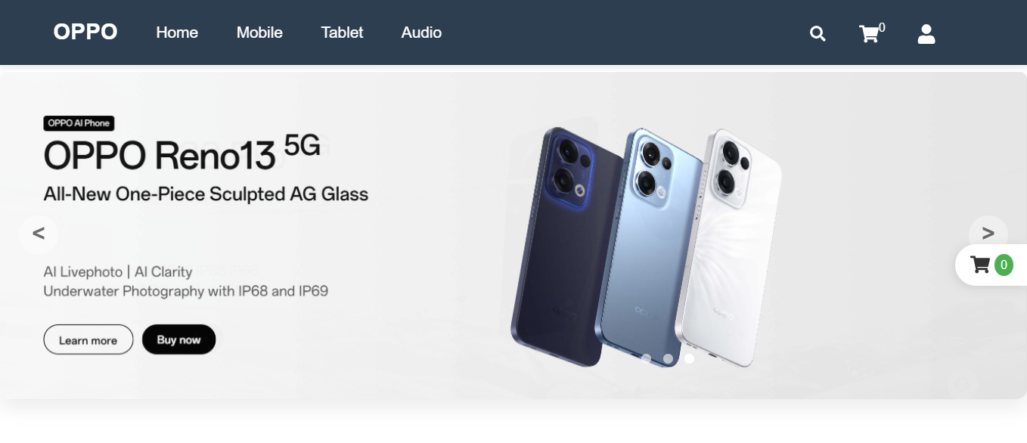
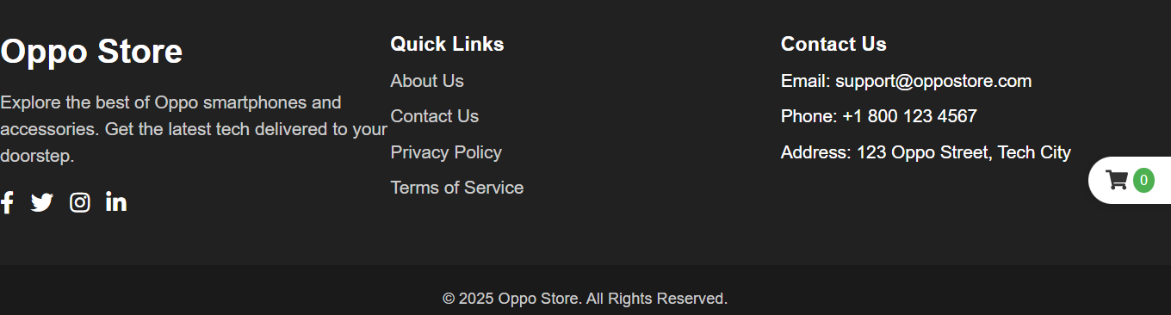

Layout Code

import Header from "./components/Header";
import TopMenu from "./components/TopMenu";
import Footer from "./components/Footer";
import {Outlet} from "react-router-dom";
const Layout=()=>{
return(
<>

<TopMenu/>

<Outlet/>
<Footer/>
</>
)
}
export default Layout;

Footer Page

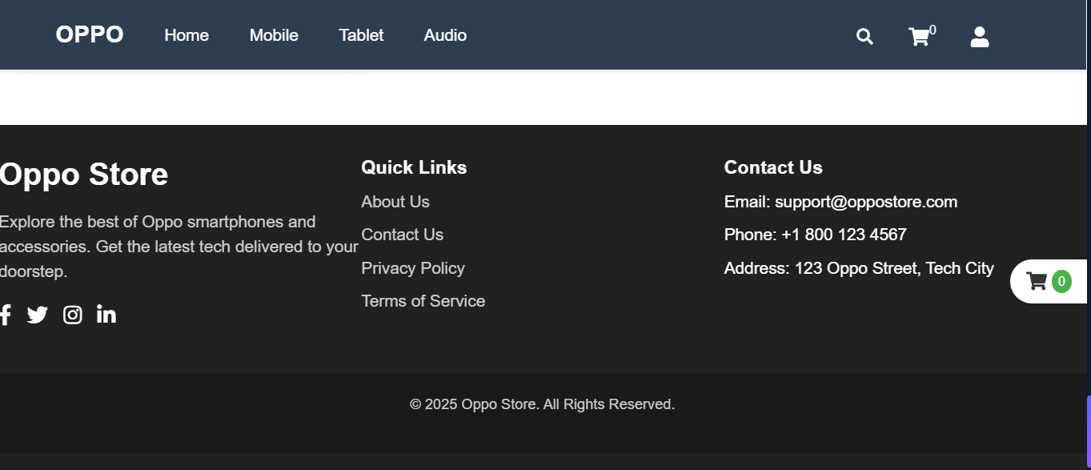

Corousal Page

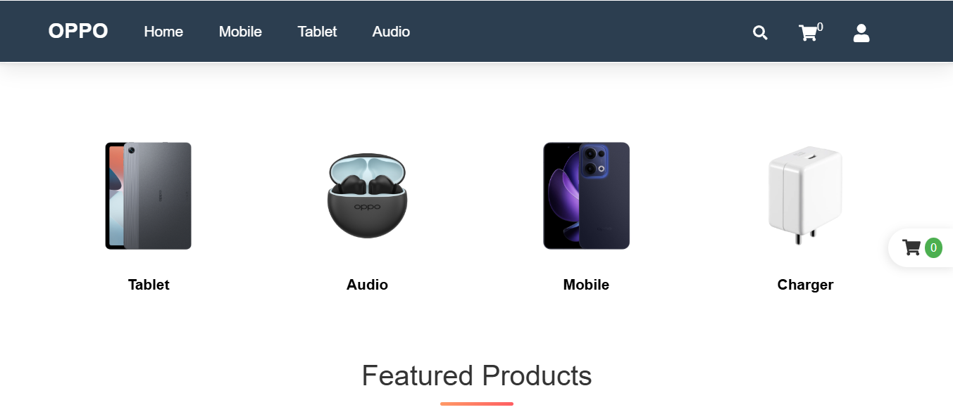
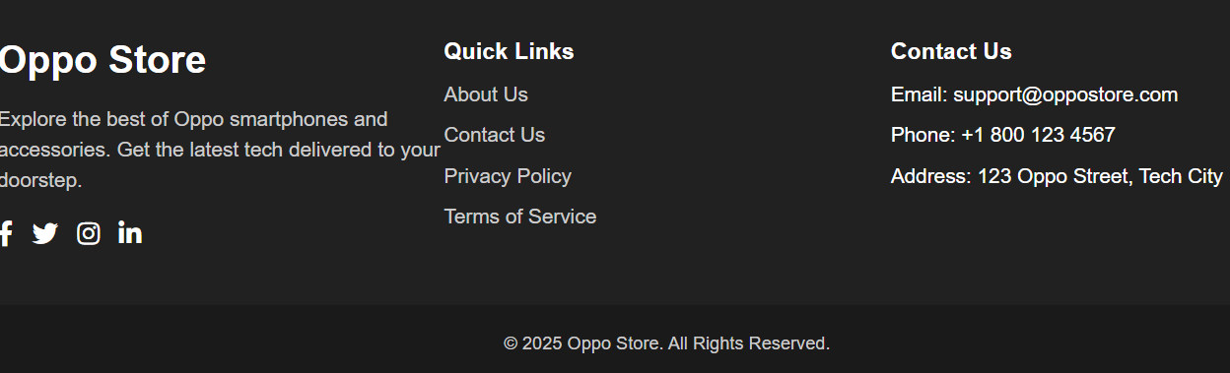
Category Page

Mobile Page

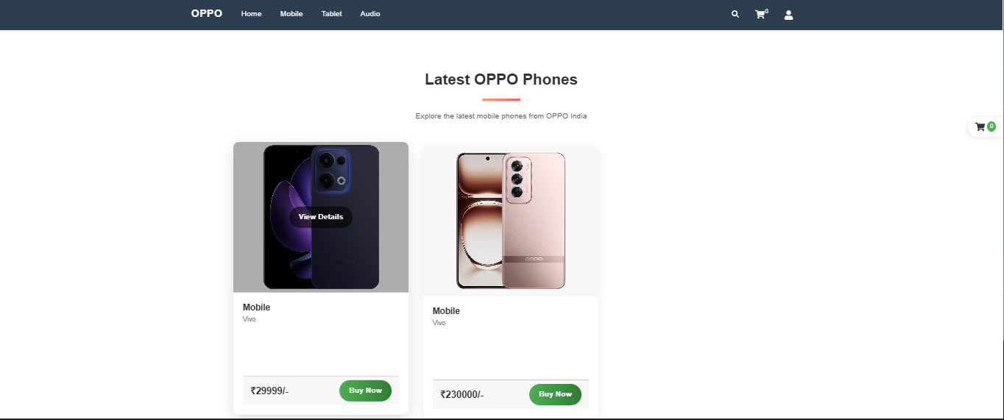

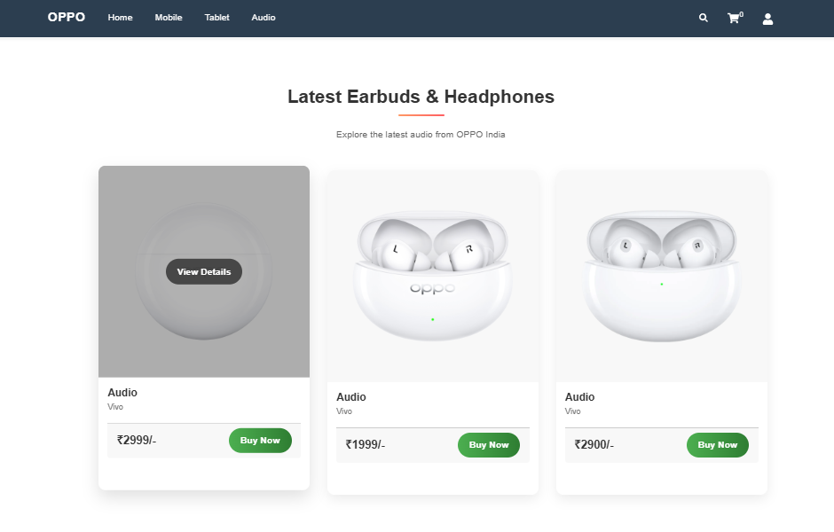
Audio Page

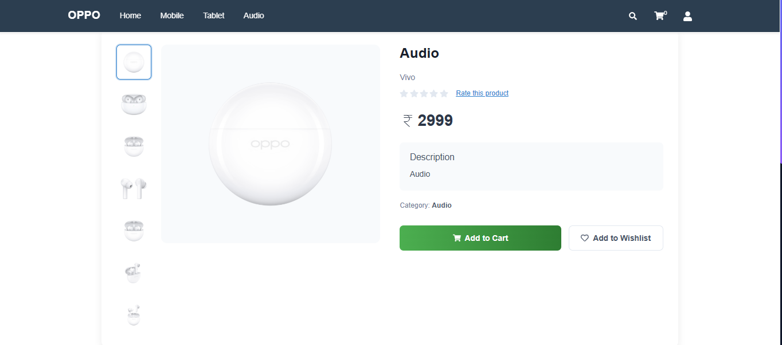
Product Details

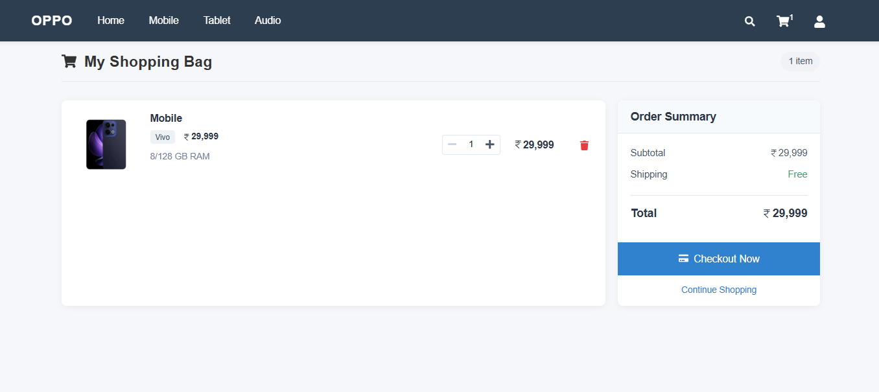
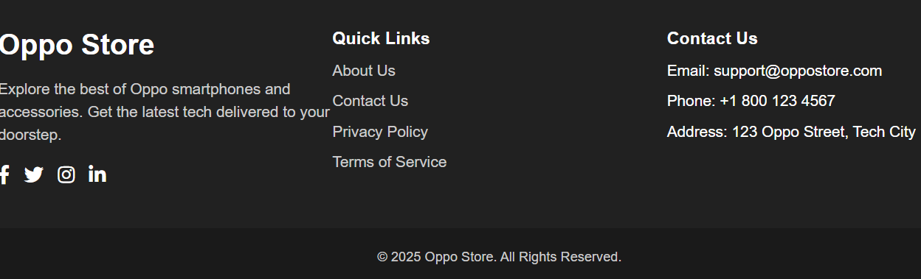
Add To Cart Page

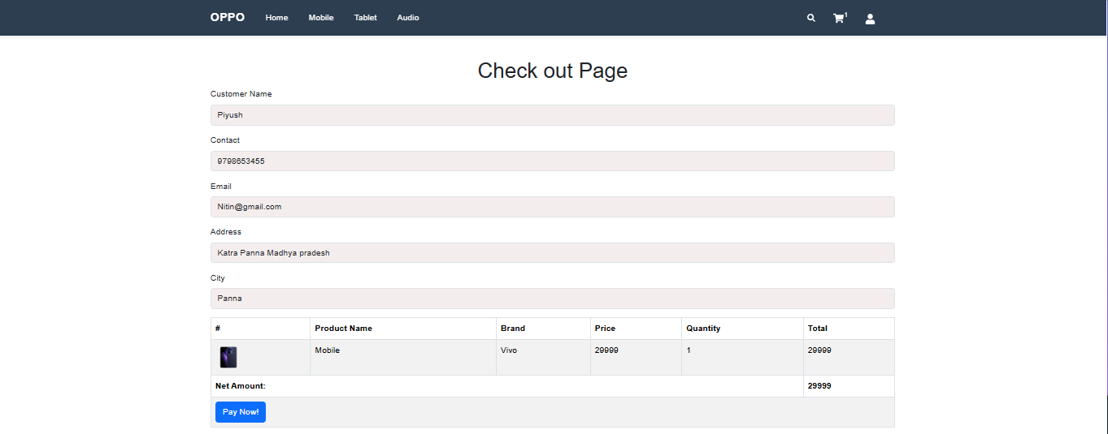
Checkout Page

Payment Page

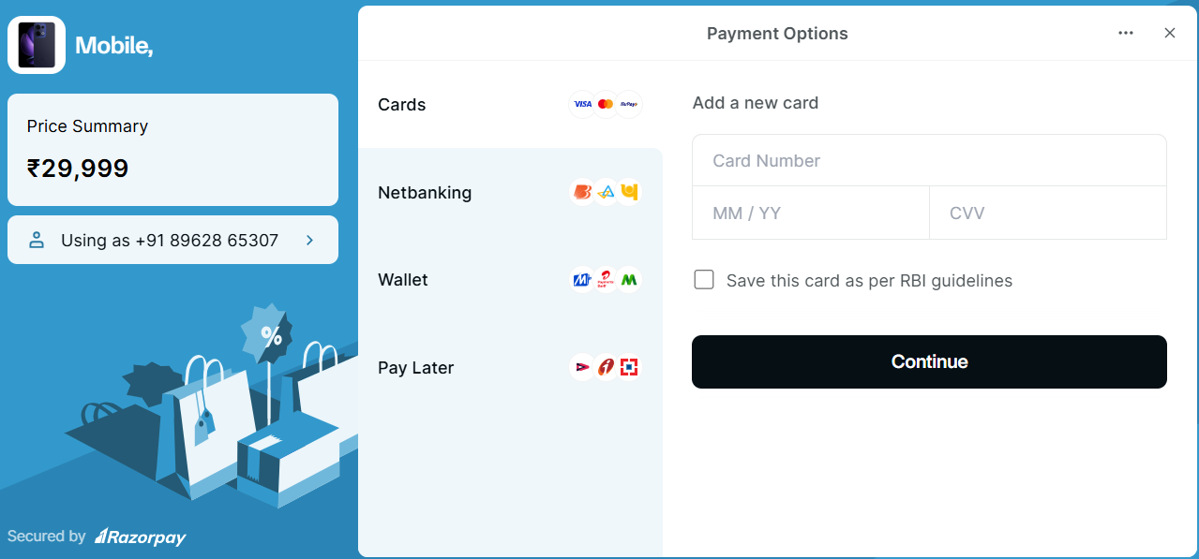
Tablet Page

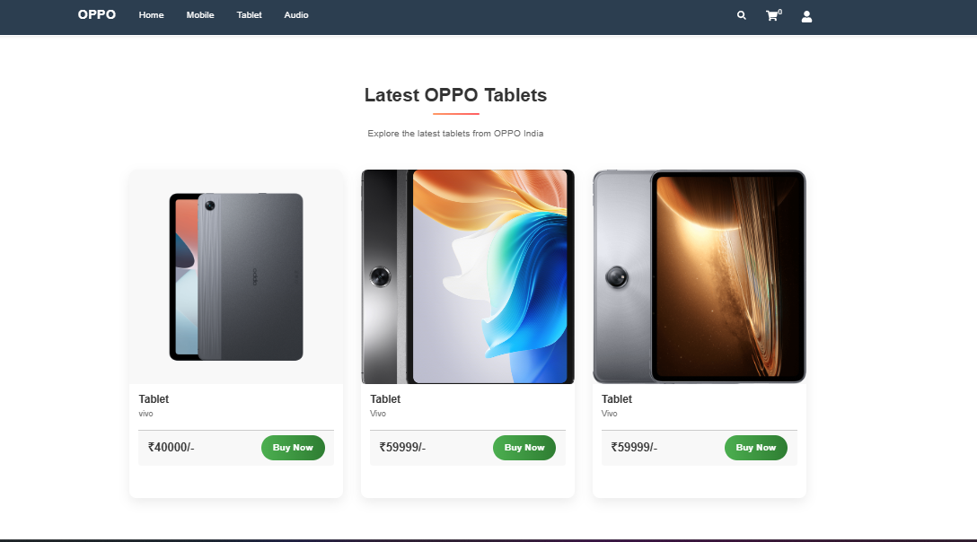

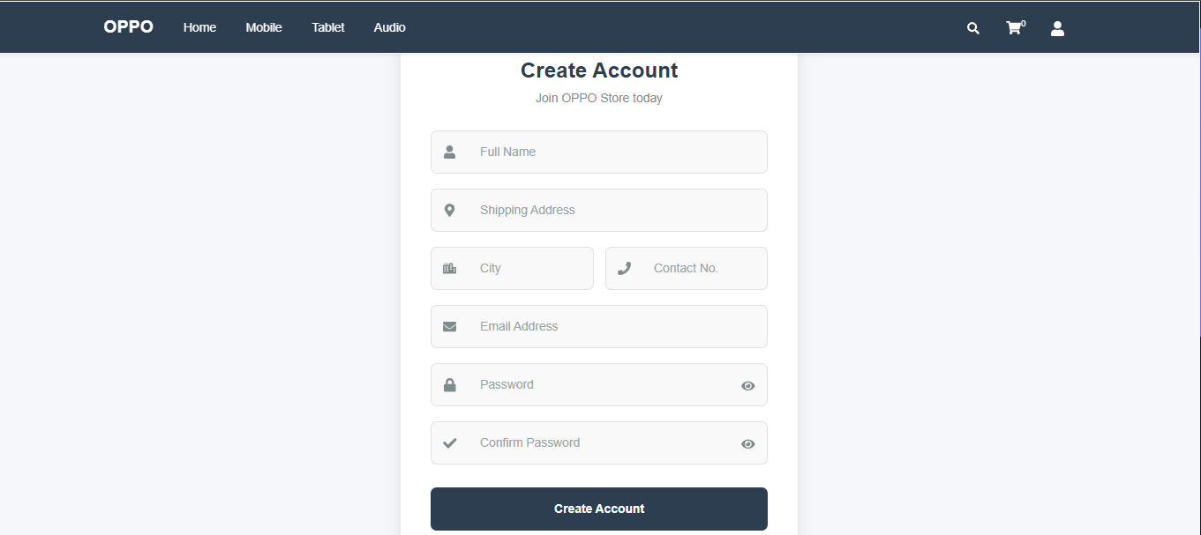
Registration Page

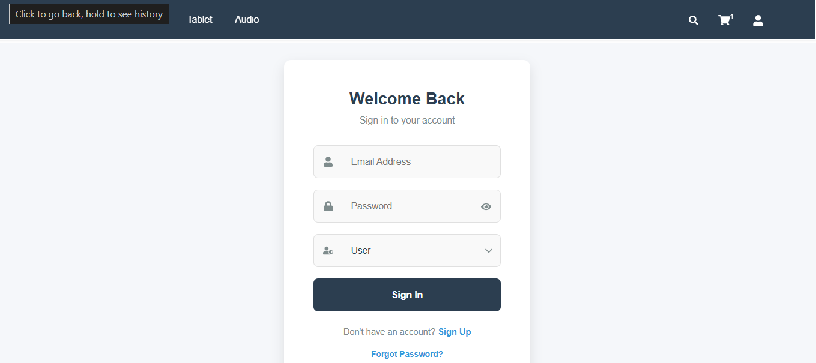
User Login Page

Admin Page
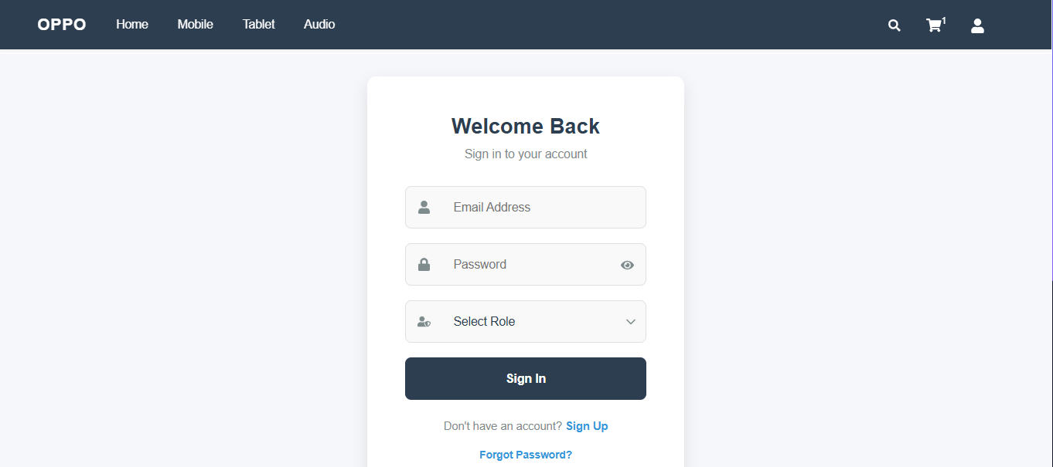

Admin Panel:-
Admin Product Insert Page

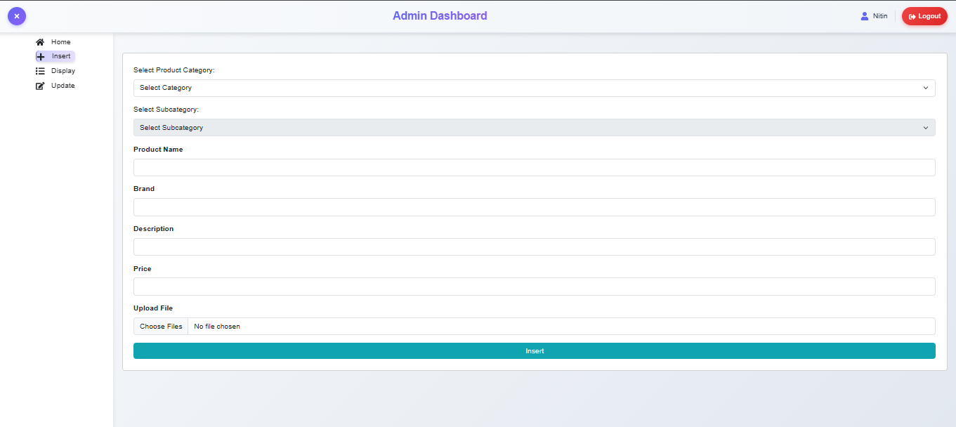

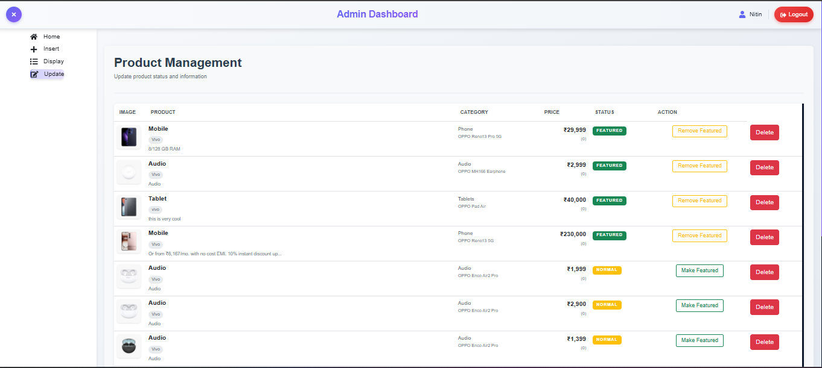
Admin Product Update Page

Conclusion

The OPPO Store E-Commerce Website is a full-stack web application designed to provide users with a seamless online shopping experience. Built using the MERN stack—MongoDB, Express.js, React.js, and Node.js—the platform offers a responsive and interactive interface for browsing and purchasing OPPO products.

Technologies Utilized
The backbone of this project is the MERN stack, a modern collection of JavaScript-based technologies that streamline the development of dynamic web applications.
- MongoDB serves as the NoSQL database for the platform. It is used to store essential data such as user credentials, product information, shopping cart contents, and order histories. The schema-less nature of MongoDB provides flexibility in handling complex data types related to e-commerce operations.
- Express.js functions as the server-side framework that facilitates communication between the frontend and backend. It handles routing, middleware, and API endpoints that enable features like product retrieval, user login, and order submission.
- React.js is used to build the frontend of the application. With its component-based architecture, React delivers a dynamic and real-time user interface that responds instantly to user interactions, making the shopping experience smooth and engaging.
- Node.js acts as the runtime environment on which the backend operates. It provides an event-driven architecture and non-blocking I/O, making the server-side of the application fast and scalable.

Key Features
The OPPO Store E-Commerce Website includes several core features that make it a fully functional and user-friendly online retail platform:
- User Authentication: Secure registration and login functionalities ensure that user data is protected. This feature uses password hashing and session/token management to maintain a secure environment for customers.
- Product Catalog: A detailed product listing showcases all available OPPO items. Each product includes essential information such as model name, price, specifications, and high-resolution images to help users make informed decisions.
- Shopping Cart: Users can add products to a virtual cart, adjust quantities, or remove items before proceeding to checkout. This interactive feature keeps users informed about their potential purchases and total costs.
- Order Management: Once purchases are completed, users can view their order history and track ongoing deliveries. This system ensures transparency and helps users stay updated on their transactions.
- Admin Dashboard: Designed for administrative control, this dashboard allows site administrators to manage the inventory, update product listings, categorize products, and oversee user accounts. This ensures that the platform remains current and secure.

